Preimplantation Genetic Diagnosis International Society (PGDIS) Annual Meeting

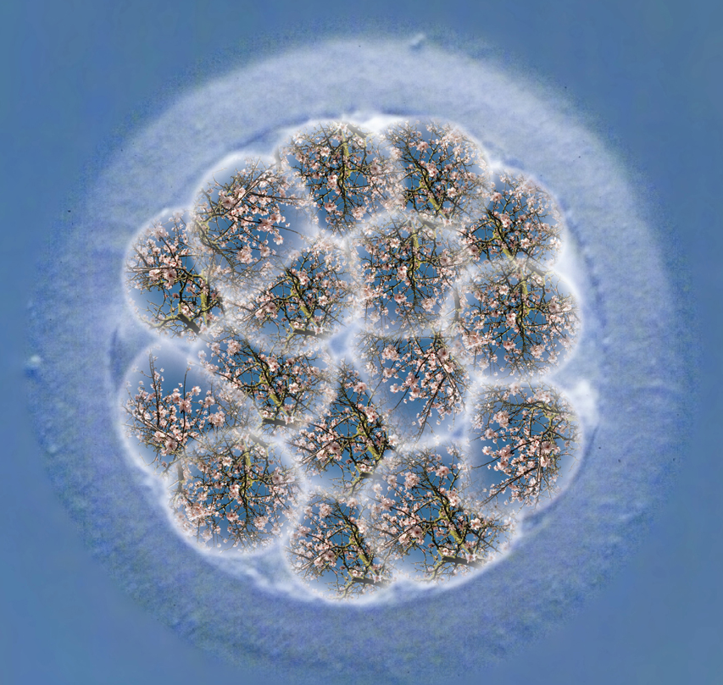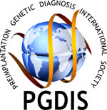

29th April – 2nd May 2014
University of Kent, Canterbury, UK
http://www.pgdis.org/

Dear Friends

It is with great pleasure that we would like to invite you to the beautiful city of Canterbury to join us for the 13th meeting of PGDIS. In 2014 PGD will begin its 25th year as a clinical procedure however its roots lie back in the 1960s with the work of our founding chairman Sir Bob Edwards.PGD has brought life and hope to thousands of families, provided fundamental insight into how we developed as humans and has, like almost no other area of medicine, raised societal, legal and ethical issues high in the public interest. With this in mind PGDIS2014 will include the following themes:
- Biology of PGD: Next generation sequencing, fate mapping, single cell analysis, origins of human development
- Time-lapse: A useful tool for PGD?
- At the cutting edge of PGD: Latest technologies for biopsy, freezing and molecular diagnostics
- The science behind PGS: Aneuploidy, meiosis, mosaicism, DNA damage, culture conditions, sperm factors
- Model species: The uses and of mammalian PGD outside the clinic
- Omics corner: Can metabolomics and transcriptomics complement or replace PGD in practice
- Clinical experienceof PGD: Dashboard of latest developments and results from around the globe
- The ethics and legalities of PGD: Why are we doing what we’re doing and should there be limits?
- The 25th year of PGD: The start of a 1 year celebration that will culminate in Chicago for PGDIS 2015

Art in ART - Gina Glover –photographer and creator of IVF imagery has agreed to support the conference and her work will be on display during the conference and in the promotional material www.artinhospitals.com

Scientific committee:
- Darren Griffin, University of Kent, Canterbury, UK (Congress Chair, Local Organizing Committee)
- Alan Thornhill, Guys Hospital, London, UK (Congress Co-Chair, Local Organizing Committee)
- Semra Kahraman, Istanbul Memorial Hospital, Istanbul Turkey
- Svetlana Rechitsky, Reproductive Genetics Institute, Chicago, USA
- Gary Harton, BlueGnome Cambridge, UK
- Alan Handyside, Bridge Fertility, Gynaecology & Genetics Centre, London, UK (Local Organizing Committee)
- Dagan Wells, University of Oxford, Oxford, UK (Local Organizing Committee)
- William Kearns, The Centre for PGD, Rockville, MD and Johns Hopkins University, USA
- Tony Gordon, Genesis Genetics, Detroit, USA
- Samir Hamamah, Art/PGD Department of University Hospital of Montpellier, Montpellier, France
- Leeanda Wilton, Melbourne IVF, Melbourne, Australia
- Nicolas Zech, IVF Centers Prof. Zech, Bregenz, Austria
- Joe Leigh Simpson, March of Dimes Foundation, New York, USA
The Keynote Lecture will be given by Professor Lord Robert Winston

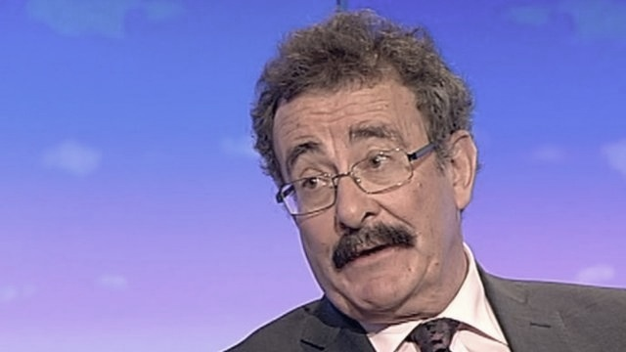
FOR SPONSORSHIP OPPORTUNITIES PLEASE CONTACT



Darren Griffin d.k.griffin@kent.ac.uk Sponsors so far:

President of PGDIS - SemraKahraman (Turkey).President Elect - Svetlana Rechitsky (USA)

