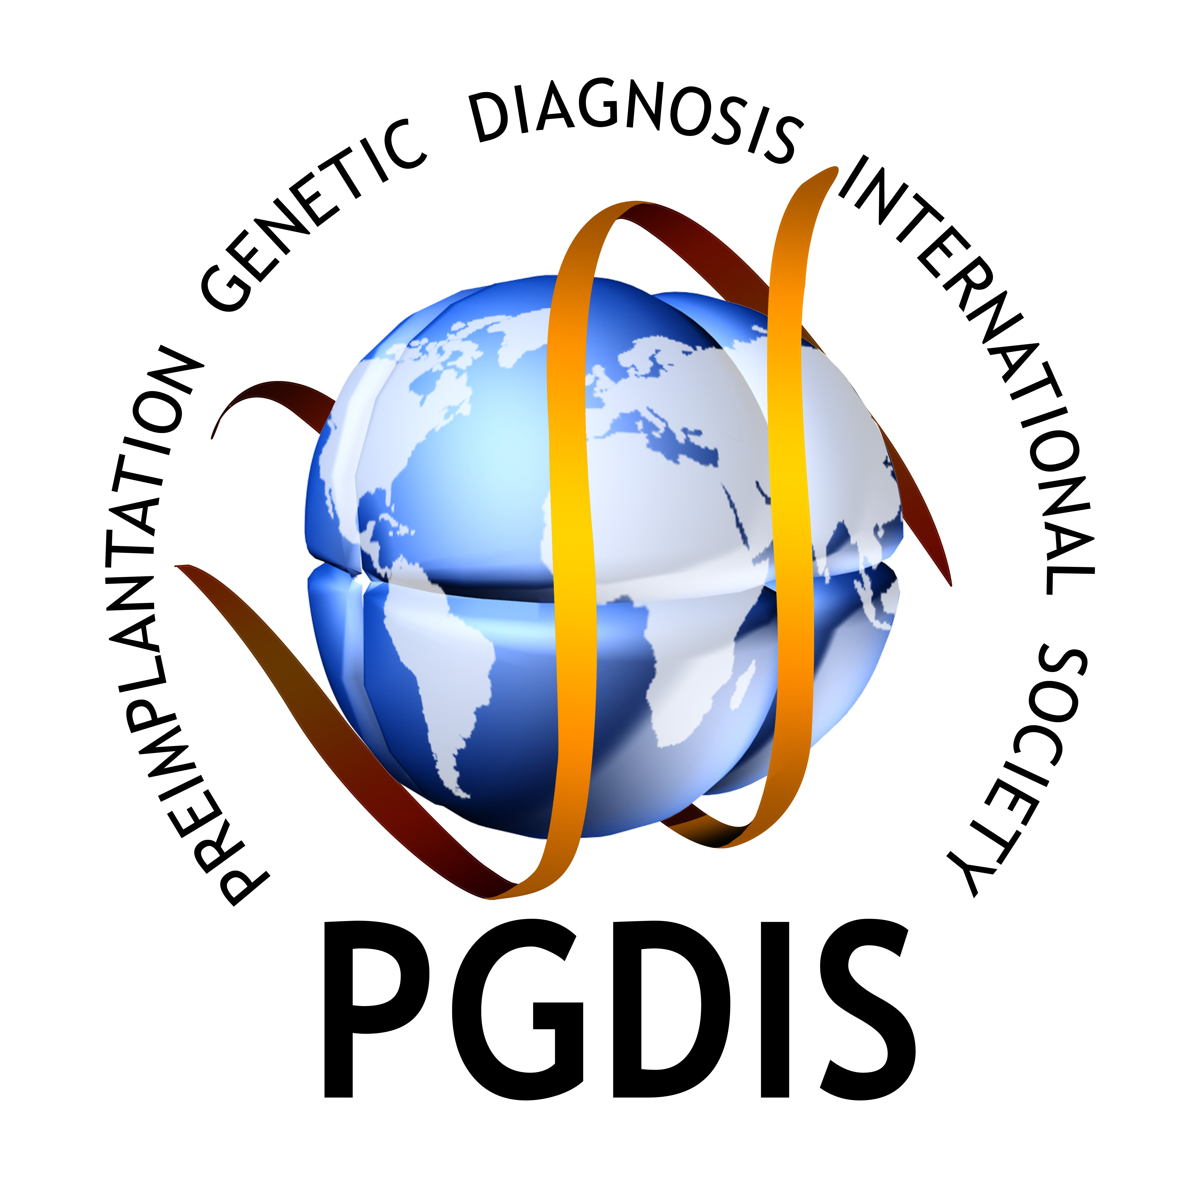
14th International Conference on
Preimplantation Genetic Diagnosis

May, 11-13, 2015, Museum of Contemporary Art
CHICAGO, USA
REGISTRATION FORM

Devoted to 25th Anniversary of PGD

Please fill and send the form by e-mail to mail@rgipgd.com or fax to 001847 144 0002

MR / MRS : TITLE

LAST NAME : FIRST NAME

INSTITUTION :

ADDRESS :

COUNTRY :

TELEPHONE : FAX
E-MAIL :

ACCOMPANYING PERSON:

REGISTRATION FEE

Pre-Conference Course | NGS
Member of PGDIS |  | $ 250
Non-member of PGDIS |  | $ 250
Student – Member of PGDIS |  | $ 200
Student – Non-Member of PGDIS |  | $ 250

 | 14th International Preimplantation Genetic Diagnosis Conference | Daily Fee |  |  | Conference Fee
Member of PGDIS |  |  | $ 250 |  |  | $ 500
Non-member of PGDIS |  |  | $ 300 |  |  | $ 600
Student – Member of PGDIS |  |  | $ 200 |  |  | $ 300
Student – Non-Member of PGDIS |  |  | $ 250 |  |  | $ 350
Accompanying Person |  |  |  |  |  | $ 150

Pre-Conference Course +
14th International PGD Conference
Member of PGDIS |  |  | $ 600
Non-member of PGDIS |  |  | $ 750
Student – Member of PGDIS |  |  | $ 350
Student – Non-Member of PGDIS |  |  | $ 450
Accompanying Person |  |  | $ 150
Please select the course in which you would like to participate:
The conference registration fee includes; admission to all scientific sessions and the exhibition, lunch and coffee break services, conference bag and documents, final program and abstract book, certificate of attendance, technical and secretarial services and Conference dinner.

The pre-conference course registration fee includes; admission to the course, lunch and coffee break services on the day of the pre-conference course.

Daily registration fee includes; admission to all scientific sessions during the selected day of attendance, admission to poster and technical exhibition during the selected day of attendance, lunch and coffee break services during the selected day of attendance, conference bag and documents, abstract book, certificate of attendance.

Important notice!
“Student” applies to undergraduate, graduate and medical students, residents and post-doctoral research trainees.
Student registrations must be accompanied by a letter from the head of the department confirming their status. Letters have to be sent to the PGDIS conference secretariat (mail@rgipgd.com). Registrations without accompanying letter will not be accepted and subsequently low fees will not apply.

Upon receipt of the registration forms with the appropriate fees, confirmation will be sent within one week.

CANCELLATION

Only cancellations made in writing (e-mail) at least 30 working days prior to the event (April 10, 2015) will be reimbursed after deduction of a $100. – handling fee. PGDIS regrets that it will be unable to consider requests received after this date. The date of the receipt of the written request for cancellation by the PGDIS secretariat will be considered as the date of cancellation. Please note that refunds will be issued only after the end of the Conference.

CONFERENCE DINNER on May 12, 2015 MCA

Registration required! Please indicate the number of people

PAYMENT OPTIONS

Bank transfer in USD: Bank transfer receipt must be sent to mail@rgipgdis.com and the name of the
participant must be mentioned clearly on the bank receipt. Please note that “all bank charges are to be paid by
the sender”.

Beneficiary : PGDIS Bank : PNC Bank
Account # :603161772 Address: 4100 W. 150th Street, Cleveland, OH 44135
Routing number: 072000915 Swift Code: NATCUS33

Credit Card: As per my registration to the 14th International Conference on Preimplantation Genetic Diagnosis,
I hereby authorize my credit card to be debited as follows:

Total Amount
Type of the Card (please circle) | MasterCard / VISA / American Express
Bank
Cardholder Name
Credit Card No
Expiration Date
(MM/YY)
CVV (last 3 digit # at the back of the card)
Signature

